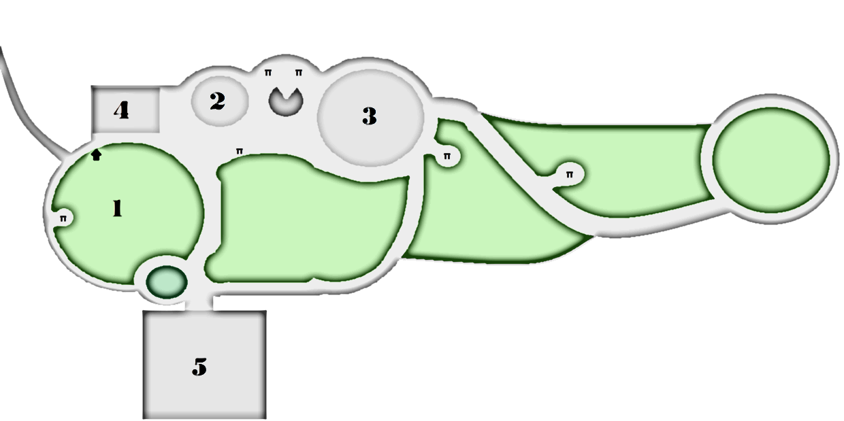**Hidden Canyon Park**

1 – Picnic Area

2 – Small Tot Lot

3 – Large Tot Lot

4 – Bathrooms

5 – Parking Lot

6 – Power Outlet

Π – Picnic Table

**Hidden Canyon Legend**